H2, H3 mysql

H2

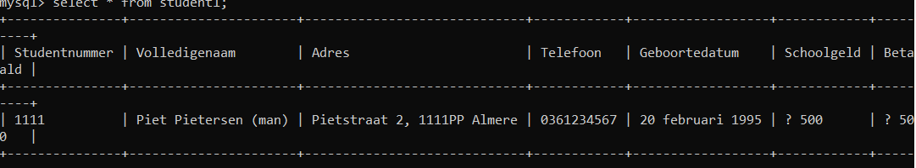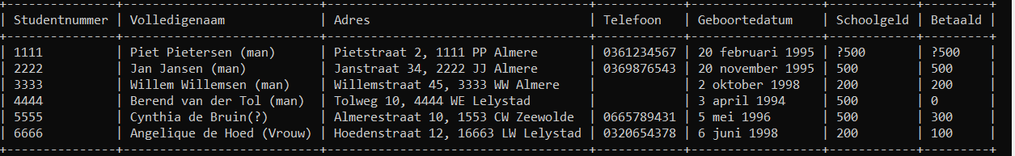

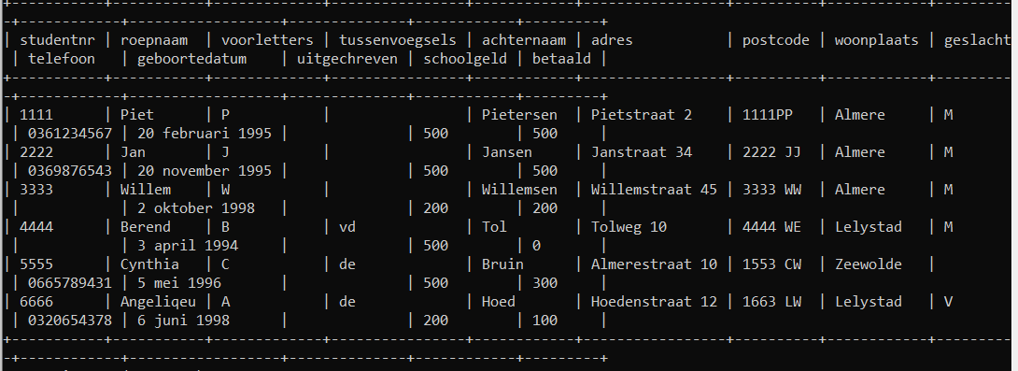

student4 (studentnr,roepnaam,voorletters,tussenvoegsels,achternaam,adres,postcode,woonplaats,geslacht,telefoon,geboortedatum,uitgechreven,schoolgeld,betaald) values("1111","Piet","P"," ","Pietersen","Pietstraat 2","1111PP","Almere","M","0361234567","20 februari 1995"," ","500","500");H3

3.2

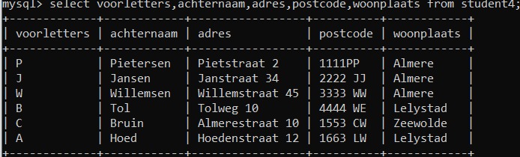

3.3

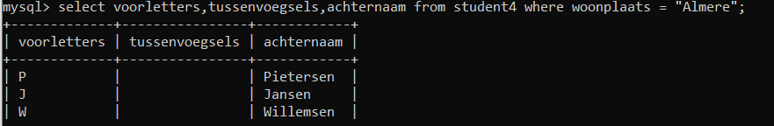

3.4

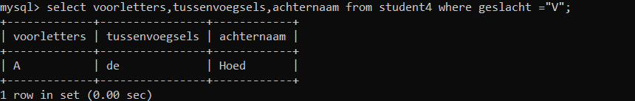

3.5

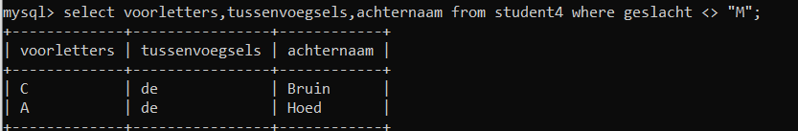

3.6

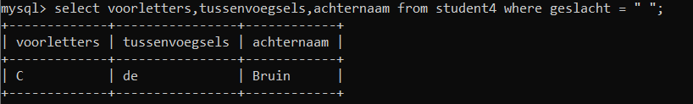

3.7

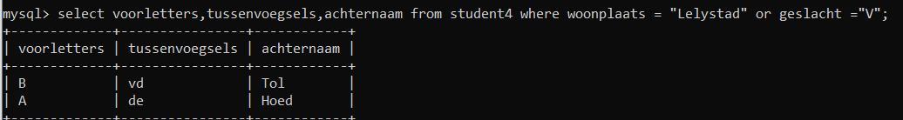

3.8

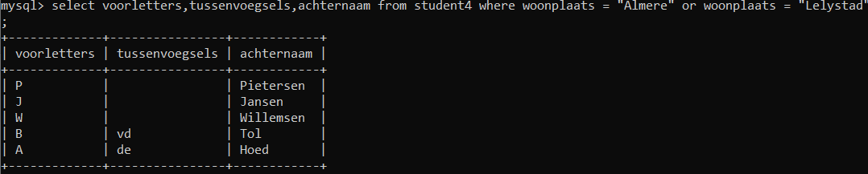

3.9

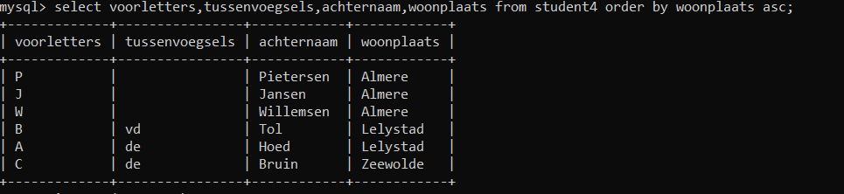

3.10

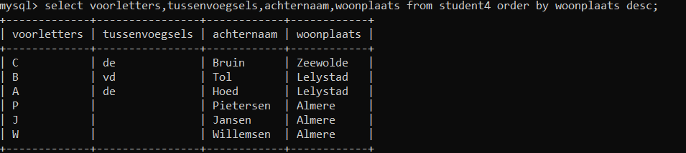

H4

4.1

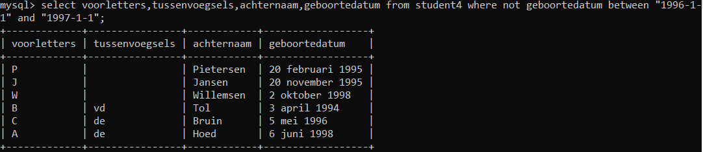

4.2



4.3

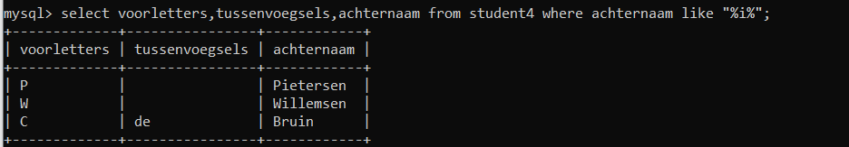

4.4

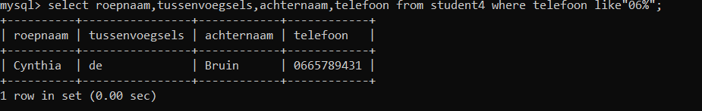

4.5

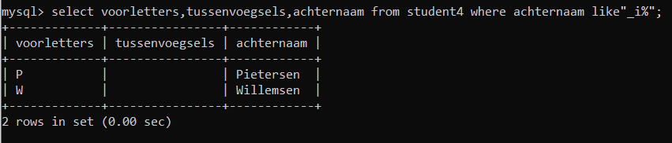

4.6

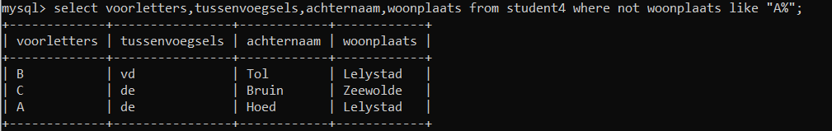

4.7

4.8

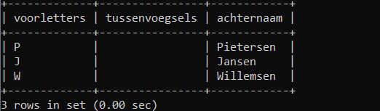

4.9

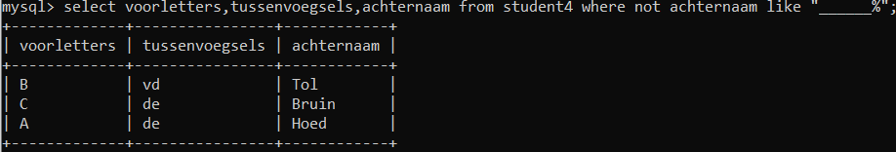

4.10

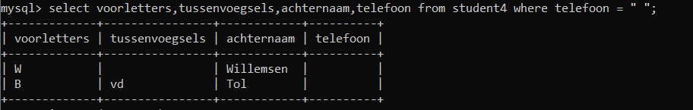

H5

5.1

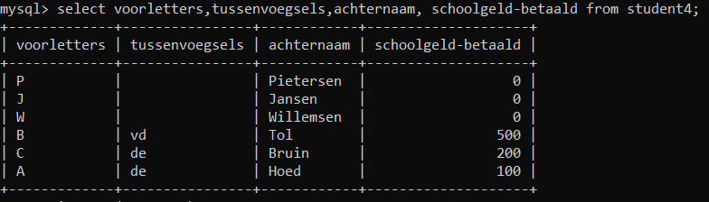

5.2

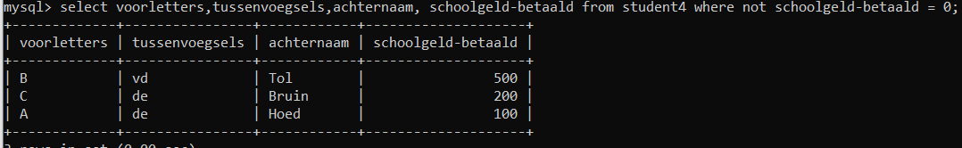

H6

6.1

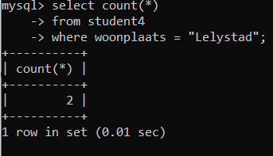

6.2

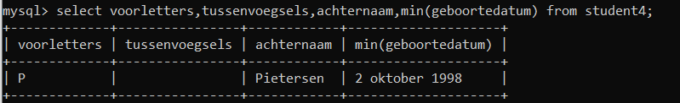

6.3

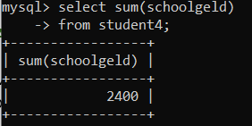

6.4



6.5

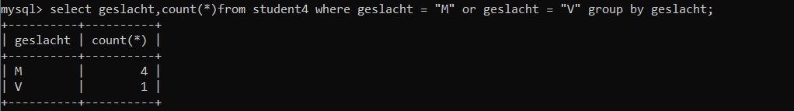

6.6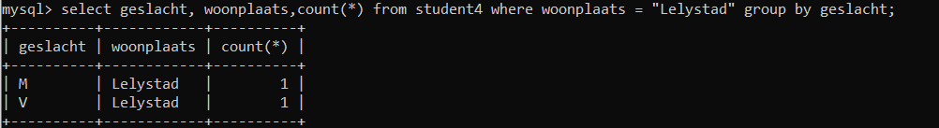

6.7

6.8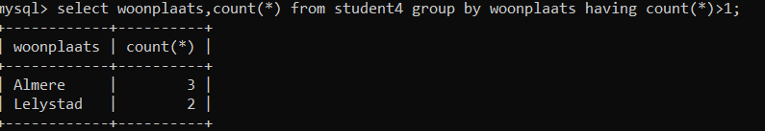

6.9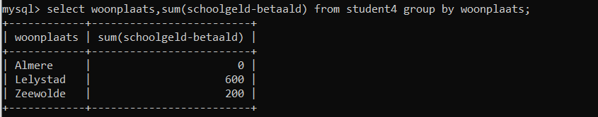

6.10

6.11

H7

7.1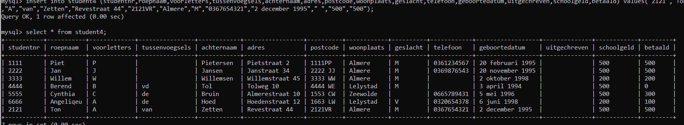

7.2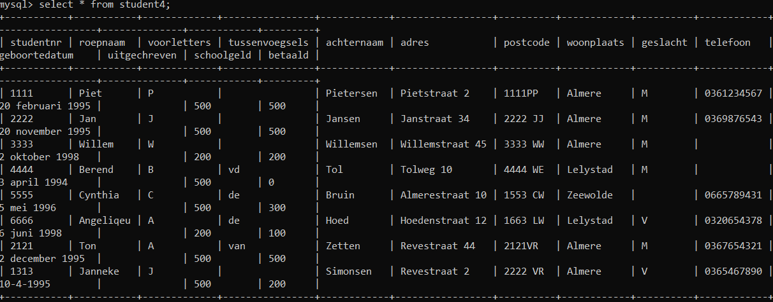

7.3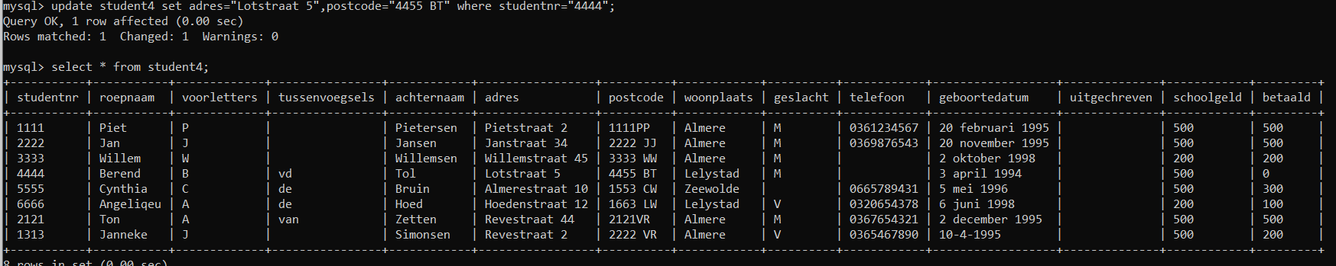

7.4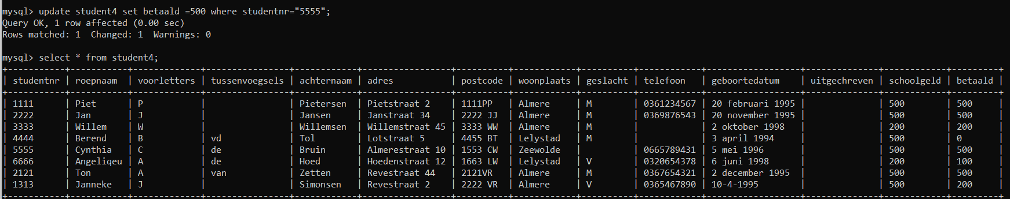

7.5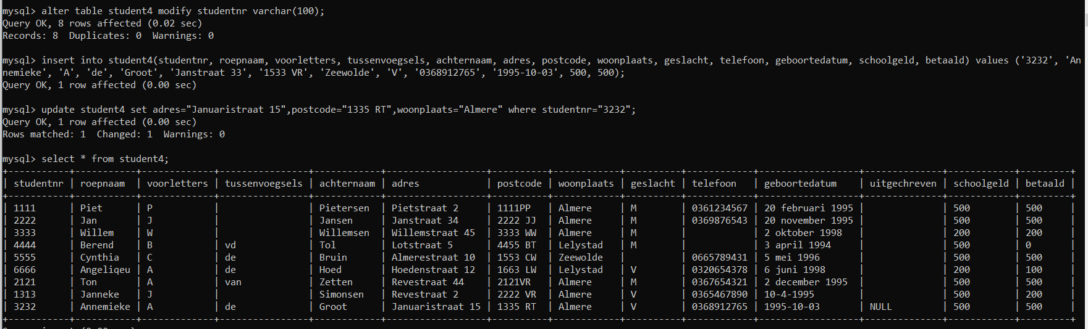

7.6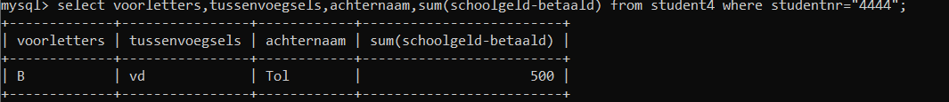

7.7

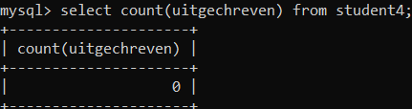

7.8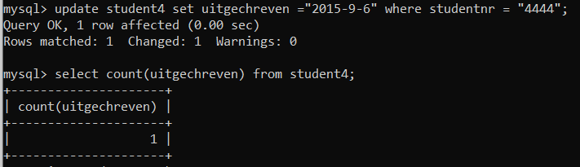

7.9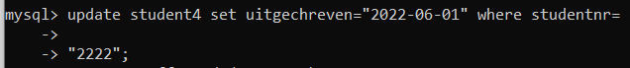

7.10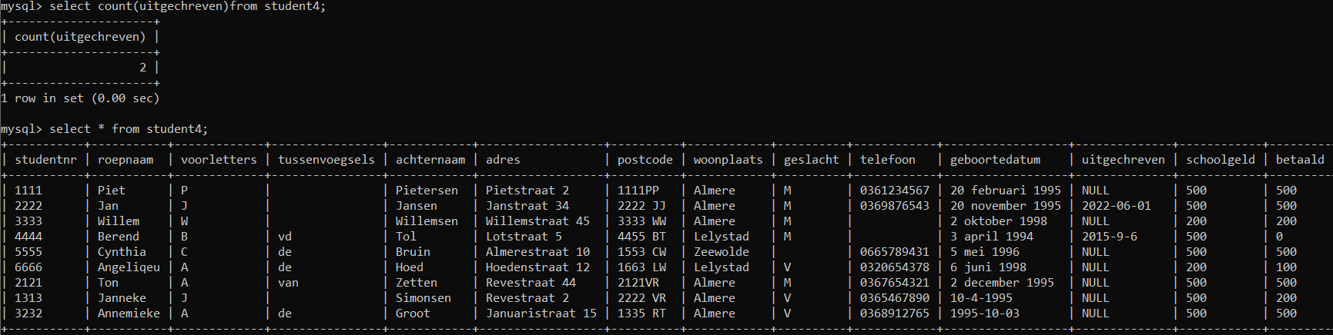

H8

8.1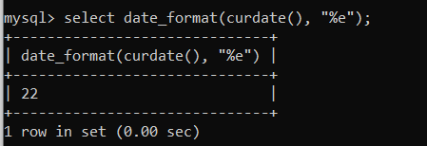

8.2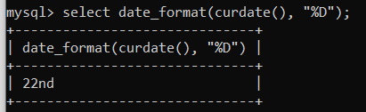

8.3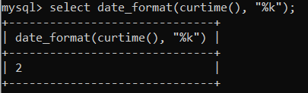

8.4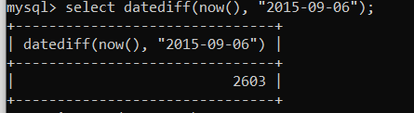

8.5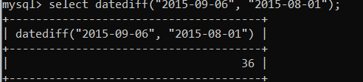

8.6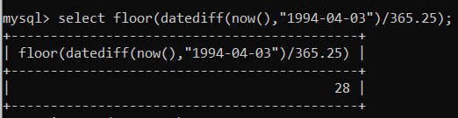

8.7